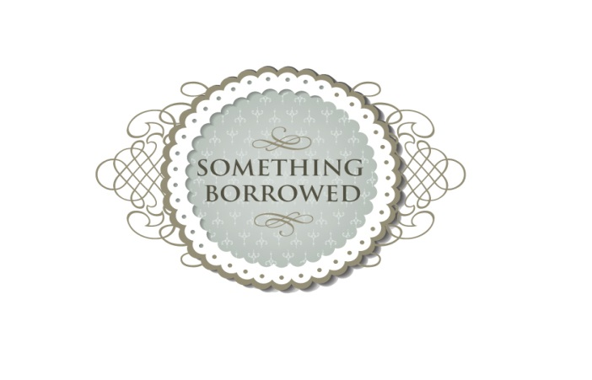
P A C K A G E S
We have put some packages together so that you can get a lot of the things you need from one supplier to save time and money!
The packages we have put together can be adapted to your needs, just give us a call and we can put together a bespoke package to suit your theme/colour scheme.
Lily
Chair cover & sash
Mirror & Vase, small candelabra or logs per table
Scatter crystals/silk petals each table
3 x glass tea-lights per table
Table number/name holder or frame for each table
Breakfast menu frame for each table
Table/seating plan
Ornate full length easel
Ex-large 80cms decorated ‘cards’ bird cage

50-70 guests £300 – saving a minimum of £45
71-80 guests £375 – saving a minimum of £60
81-100 guests £425 – saving a minimum of £70
101–125 guests £465 – saving a minimum of £80

Peony
Chair cover & sash (with additional sash, including)
40cms Mirror plate, 60cm Martini Vase, Conical Vase, Candelabra, bird cage, Bell jar or double logs per table
Scatter crystals/silk petals each table
3 x ribbed silver or pink tea-light holders per table
Table number/name holder or frame
Breakfast menu holder/frame
Table/seating plan
Ornate easel
Ex-large 80cms decorated ‘cards’ bird cage or similar cards holder
Around the room small bird cage & tea light holders
Various signs

50-70 guests £375– saving a minimum of £105

71-80 guests £445– saving a minimum of £130

81-100 guests £500 - saving a minimum of £145

101 – 125 guests £575 – saving a minimum of £170

You might want to add or replace/upgrade items from our finishing touches or props range….talk to us, we aim to please ☺

